

**CHEMICAL RECYCLING OF PLASTIC WASTE**

**TOBB ETU Materials Science and Nanotechnology Engineering**

**Arda Kurucu**

**Öykü Sevimli**

**Çağdaş Güven**

**ABSTRACT**

**CHEMICAL RECYCLING OF PLASTIC WASTE**

Kurucu, Arda

Güven, Çağdaş

Sevimli, Öykü

Assoc. Prof. Zeynep Obalı

April 2021

**ABSTRACT**

Each year demand of plastic products increases and with it output of plastic waste increases. Traditional methods of energetic and mechanical recycling are not enough to address the need for rate of recycling. Currently various methods of polymer recycling more specifically chemical recycling are studied and improved. These methods result in a more desirable products such as monomers, resins allowing the production of virgin-grade materials. However, some polymers are only recyclable through specific methods. Most common methods of recycling are summarized, their advantages and disadvantages discussed. Thermal routes such as pyrolysis can be used on mixed plastic wastes however, impurity polymers like PU and PET can cause serious problems and stop the operation. Whereas methods under solvolysis can only be used on these polymers since they are composed of ether and ester bonds. Aim of this review article is to gather information and create a general overview of the subject chemical recycling of polymers. Some processes are described with a specific polymer and its method to create a better understanding of them.

**TABLE OF CONTENTS**

ABSTRACT

TABLE OF CONTENTS

CHAPTERS

1. GENERAL INTRODUCTION
   1. INTRODUCTION
   2. EXISTING REVIEW ARTICLES
   3. SCOPE OF THE REVIEW ARTICLE
   4. ROLE OF CHEMICAL RECYCLING IN ECONOMY
2. CURRENT METHODS FOR CHEMICAL RECYCLING
   1. THERMAL ROUTES
      1. PYROLYSIS
         1. CATALYTIC PYROLYSIS
         2. MECHANICS OF REACTION
         3. HYDROCRACKING AND OTHER METHODS
         4. NEW REACTOR DESIGNS
            1. CONICAL SPOUTED BED REACTOR
            2. BATCH AND SEMI-BATCH REACTOR
            3. FIXED AND FLUIDIZED BED REACTOR
      2. GASIFICATION
         1. DIFFERENT PLASTIC WASTE FOR GASIFICATION
         2. REMOVING UNWANTED GASES FROM GASIFICATION PROCESS
         3. GASIFICATION PROCESS FOR PP AND PE
         4. TWO-STAGE GASIFICATION PROCESS
   2. SOLVOLYSIS
      1. HYDROLYSIS
         1. ALKALINE HYDROLYSIS
         2. ACID HYDROLYSIS
         3. ENZYMATIC HYDROLYSIS
      2. GLYCOLYSIS
      3. ALCOHOLYSIS
      4. AMINOLYSIS
   3. DISSOLUTION/PRECIPITATION
3. CONCLUSION
4. REFERENCES
5. **GENERAL INTRODUCTION**
   1. **INTRODUCTION**

Plastics are mass-produced in 1950s. Plastics have many applications such as commercial, agricultural, industrial. Plastics are a highly demanded material. Because plastics have lightweight, low maintenance requirements, weathering resistance, low toxicity, transparency, and low price. Therefore, in the process of time, plastic waste has become an urgent issue. In 1970s, plastic recycling is started. Because most of the time, plastics are recycled separately, a code system is invented in 1988 by the Society of the Plastic Industry. Most of the recyclable plastics are PET, PE, PVC, PP, PS. Therefore, they are got codes. (Figure 1). However, Plastics cannot recycle with any known process early time of the plastic industry. In 1980s, plastic industry leaders of the US make a false announcement saying that plastic is recyclable and spend 50 million on this campaign. Because they notice consumers satisfied with plastics and demanding more. The report about plastic recycling states that in 2017 only 8% of plastics are recycled in the US. Even though, they put codes on plastics, sorting and recovery of plastic is more costly than producing plastics from virgin plastics. Recycled plastics have lost their quality and still needed adding virgin polymer. [31,32,33,36,37]

ok içeren bir resim

Açıklama otomatik olarak oluşturuldu

Figure 1.1:code of plastics[44]

The US is sent 70% of their plastic waste to China until 2017. Also, European Union sent %90 percent of it. In 2017, China is carrying out Operation National Sword policy and limited importation of plastic waste. Because the most of imported plastic wastes were low quality and not recyclable. Also, contaminated plastic wastes are caused by environmental pollution. Nowadays, European countries are sending their waste plastics to Turkey, India, Malaysia, and Vietnam. [34,35]

Plastics have cause many environmental issues. However, replacing plastics with other material solves the problem like metal, glass, paper because of their environmental pollution by producing. Most of the plastic waste ends up with burying in landfill (Figure 1. 2) or incineration (Figure 1.3) Burying in landfill take large space, therefore; to reducing the amount of plastic waste on landfill , incineration method is implemented. The incineration method is made from electricity from plastic waste. Incineration of plastic waste is caused by carbon emissions five to ten tons from one ton plastic waste. [39,40]

gök, duman, açık hava, bina içeren bir resim

Açıklama otomatik olarak oluşturuldugök, açık hava, doğa, kalabalık içeren bir resim

Açıklama otomatik olarak oluşturuldu

Figure 1. 2: Landfill [45] Figure 1. 3: Incineration[46]

Mechanical recycling is needed pure plastic waste to recycle. This method doesn’t convert polymer to the monomer, therefore; it is a physical method. Thermoplastics can be recycled by the method, however; other polymers cannot recycle by the method. Heterogeneity plastic waste is difficult to recycle by the method. The method is cheap and used worldwide. One of the drawbacks of this method is that complex plastics is very costly because of the extra processes. Other one is recycled polymers have low quality than virgin polymers. In 1980s and 1990s, this method failed because of these reasons. Step of this method are in order, collection, segregation, cleaning, drying, chipping, sizing, coloring, agglomeration, palletization, extrusion and finally manufacturing the final product. [39,43]

Chemical recycling is converted polymer to the monomer, oligomers by depolymerization. Because this method changes the chemical structure of the polymer. There are sixty companies work on chemical recycling such as Eastman Chemical Company, Brightmark Energy in 2019. Chemical recycling methods are such as pyrolysis, gasification, [thermal cracking, catalytic cracking, solvolysis, hydrolysis, glycolysis aminolysis, dissolution. Product of chemical recycling can use as fuel. Chemical recycling will be discussed in detail later in this article. [40,41,42]

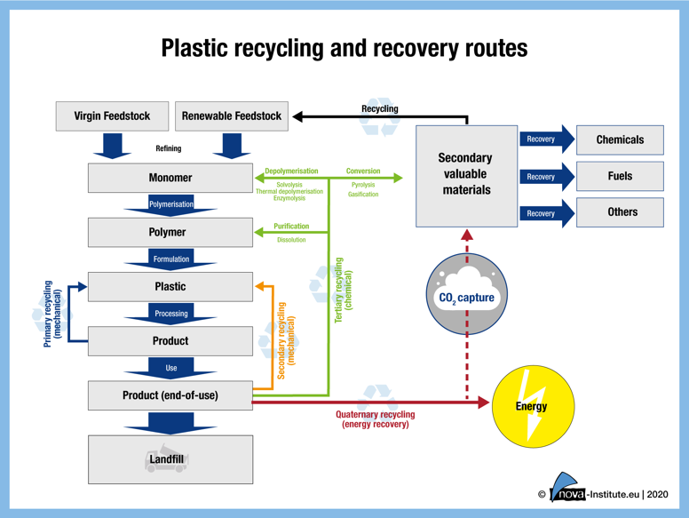

Figure 1. 4: recycling method of waste plastic [47]

PET (polyethylene terephthalate) is one of the most recycled polymers and semicrystalline thermoplastic polyester. PET is invented in 1941. PET has many applications such as disposable soft-drink bottles (Figure 5), fibers, photographic films. PET is started mass production for textile fibers in 1940s. PET is nontoxic, durable, transparence, therefore; it makes PET have high demand on the market. However, PET is nonbiodegradable, therefore; PET cannot be sent to landfills. Chemical recycling is the most satisfying choice for recycling.[39]

şişe, içme suyu, açık içeren bir resim

Açıklama otomatik olarak oluşturuldu

Figure 1.5: application of PET[48]

PVC (polyvinyl chloride) is the first modern plastic that is discovered by German chemists in 1872. PVC (polyvinyl chloride) stays in nature for 30-40 years. PVC is used automotive industry, medical devices, wire, pipes(Figure 6). Incineration method for PVC is caused pollution, therefore; chemical recycling would be a better method. [39]

metin, ampul içeren bir resim

Açıklama otomatik olarak oluşturuldu iç mekan içeren bir resim

Açıklama otomatik olarak oluşturuldu

Figure 1. 6: Applications of PVC[49,50]

PE (Polyethylene) is invented in 1898 by German chemists. HDPE (high-density polyethylene) is made from PE by 6-7 atm pressure and approximately 333-343 K temperature. On the other hand, LDPE (low-density polyethylene) is made by 1000-5000 atm pressure and 520 K temperature. HDPE is strong, high density, tough because of high degree crystalline structure. On the other hand, LDPE is fragile by low degree crystalline structure. Applications of PE (Polyethylene) (Figure 7) are packaging film, domestic ware, tubing, squeeze bottles, and cold-water tanks. [39,62,63,64]

iç mekan, mavi, sabit, plastik içeren bir resim

Açıklama otomatik olarak oluşturuldu

Figure 1.7: Applications of PE[51]

Polypropylene (PP) is a thermoplastic polymer and invented in 1951. PP has a very low density of about 0.895 and 0.92 g/cm³. Because PP is flexible and tough and resistant to fatigue, it has many engineering applications. Applications of PP are tapes, automotive components, laboratory equipment, electronic devices, furniture. [56,57,58]

iç mekan, kontrol paneli, projektör içeren bir resim

Açıklama otomatik olarak oluşturuldu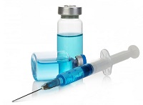

Figure 1. 8: Applications of PP [52,53]

Polystyrene (PS) is a thermoplastic polymer and invented in 1839. PS is transparent, tough. PS is usually recycled by the incineration method. Applications of PS are packaging, household, medical items. [55,59,60,61]

iç mekan, mutfak aleti içeren bir resim

Açıklama otomatik olarak oluşturuldu

Figure 1.9: Applications of PS[54]

* 1. **SCOPE OF THE REVIEW ARTICLE**

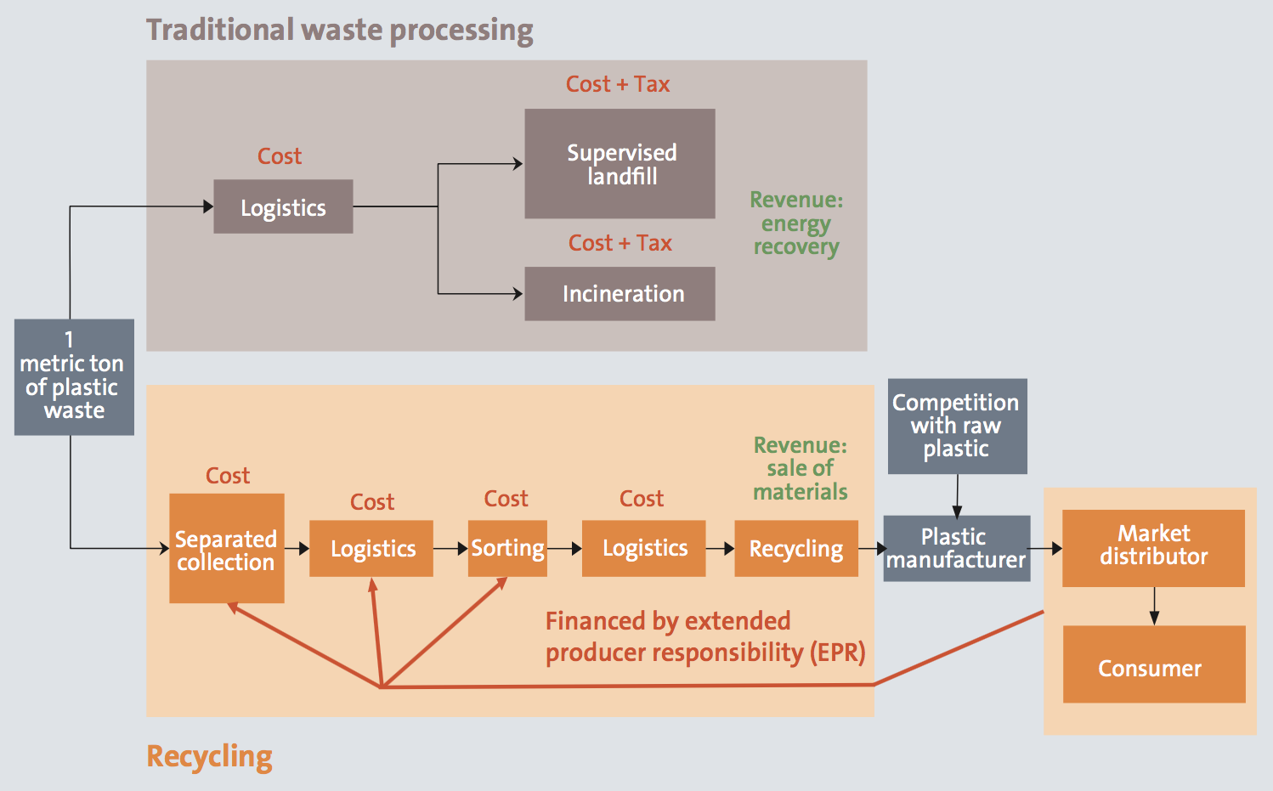

Figure 1.10: General pathway of waste plastics [30]

This review article focuses on mainly chemical recycling of waste plastics. Which is considerable greatest problem of our century. Reviewed articles highlight number of recent innovations, conventional and unconventional methods and ideas for their own ways of solution. Main idea is to help some outstanding problems or/and replace existing methods and mechanisms with consistent counterparts. As for creating a great scheme, the article aims main methods proposed from many researchers around the globe. Since production of plastics/polymers increases over time, it is important us to keep balance in manufacturing and consuming loop. As one of the most used method, land filling, could not keep annual waste in healthy environment as for biomes around them. Incineration, which is other main methods for dealing plastic waste also creates increasing excessive amount of Carbon dioxide molecule and emits into atmosphere thus creating a workload on natural recycling that is provided by organisms such as bacterial and plants . In regards of amount of material released it is logical to consider collectible market and manufacturable material laying under contaminants. Sections in this review article also selected from promising fields of research. Following sections establishes pathway for understanding scientific meaning of plastic waste problem and firstly in brief version of general processes and methods and following with in depth understanding of mechanisms for mentioned processes and methods which are still open for improvements.

1. **CURRENT METHODS FOR CHEMICAL RECYCLING**

|  |  |
| --- | --- |
| Name of Process | Description |
| Mechanical Recycling | Plastic waste is subjected to physical process (grinding, melting, etc.) in order to produce a finished product. Melting and re-extruding the waste plastic is the most seen method. |
| Chemical Recycling | Chemical modifications are created by cracking bonds, rather than simply changing the structure and macroscopic properties of the plastic. Depolymerization of the polymer into monomers is often the target. These can be used to synthesize new polymers, but they can also produce other chemical building blocks. Feedstock recycling refers to the recycling of feedstocks used to manufacture new polymers, which can be monomers or a crude oil-like substance that can be fed to steamcrackers to create monomers. |
| Depolymerization | Breaking polymer bonds to produce monomers or oligomers. Due to side reactions or contact with a reactive medium present during depolymerization, other side products are often formed. |
| Thermochemical routes | Both processes that sever polymer bonds exclusively by the input of thermal energy (e.g., pyrolysis, hydropyrolysis, and gasification) are included. This can be done in either an inert (N2) or reactive (H2 or O2) environment. These processes are most often used for polyolefins, but they've also been tested for PS, PET, PMMA, and other polymer impurities. |
| Pyrolysis | Thermal radiation breaks the molecular bonds of plastic during pyrolysis (-lysis, Greek for dissociation). The plastic is heated in an inert atmosphere (such as N2) until permanent gases, oils, and waxes form. Typically, this process produces a highly mixed hydrocarbon stream. Based on whether or not a catalyst is used, this mechanism is referred to as catalytic cracking or thermal cracking. Pyrolysis or hydropyrolysis under pressure is referred to as liquefaction.. |
| Hydropyrolysis | Under H2 atmosphere, plastic thermally degrades. Hydrogenolysis is described as the cleavage of C-C bonds followed by hydrogenation on a monofunctional metal catalyst. The same method may be carried out on a monofunctional acid catalyst or a bifunctional catalyst on both a metal and an acid site (bifunctional hydrocracking). |
| Solvolysis | Solvolysis can only be used to break C-C bonds in polymers with heteroatoms in their backbone. Hydrolysis, alcoholysis (glycolysis and methanolysis), phosphorolysis, ammonolysis, and aminolysis are the solvolysis processes named after the cleavage agent used. This method will cleave ether, ester, and acid amide bonds. |
| Dissolution  Precipitation | A plastic containing additives and impurities of other polymers or materials is dissolved in this phase. To selectively dissolve the target polymer, a solvent is chosen.Filters are used to remove unwanted additives, and the desired polymer is precipitated. Dissolution/precipitation is not strictly speaking a chemical recycling mechanism since no bonds are normally cleaved. However, since understanding the solvent/polymer relationship, solvent nature, and solvent recovery requires chemical fundamental information, this mechanism is covered in this perspective and is often referred to as chemical recycling. |

**2.2. THERMAL ROUTES**

**2.2.1. PYROLYSIS**

Pyrolysis is a process that works on high temperatures in an inert atmosphere. [1]. Through recycling industry, it is one of the most used methods on waste plastics. While oil has been most used resource for synthesis for most of the virgin grade polymers, Pyrolysis enables the path to the reverse route thus oil can be produced from waste plastics. Pyrolysis is one of the most used process also named as Thermal Cracking. It is also possible to produce diesel fuels above %40 percent for certain polymers.

Pyrolysis can be used recover fuel and monomers [3], however for number of polymers it is impossible to recover desired product. PET, PVC are examples of such polymers. The reason for failure is HCl requiring half of the energy needed to break C-C bonds in Polyene. Thus, kinetically selectively breaking mentioned bonds create achallenge. Monomer recovery is actually an efficient method for polymethylmethacrylate (PMMA) and Polystyrene (PS)[2].

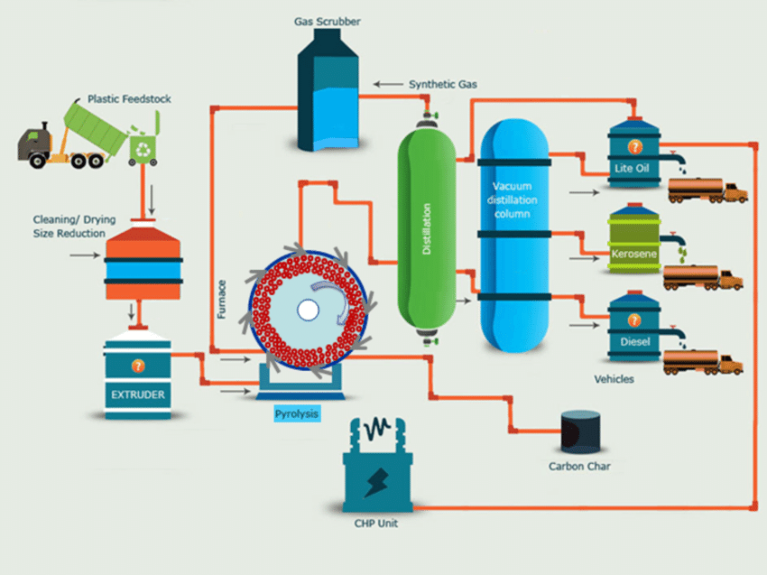

Figure 2.1: Process Flow Diagram of Pyrolysis plant[28]

Polyolefin recovery on the other hand is a promising field. New approaches show more efficient setups for monomer recovery from Polypropylene. Catalytic pyrolysis, tandem alkane metathesis/transfer hydrogenation catalysis, and unselective hydrocracking are examples of waste polymer transformations that turn raw materials into a lower value, wide distribution of smaller molecular fragments like aromatics and light hydrocarbons at temperatures above 500 °C. [4]

The pyrolysis process has an advantage over conventional recycling methods since it does not require a thoroughly complex process. Many plastics are incompatible with one another in the recycling process and cannot be recycled together. For example, a small amount of PVC contamination in the PET recycling stream can destroy the whole PET resin, turning it yellow and brittle and necessitating reprocessing. This demonstrates that the recycling process is so vulnerable to pollutants that all plastics must be separated by resin form, colour, and clarity. The pyrolysis process, on the other hand, seems to be more sustainable, as liquid oil can still be extracted from the mixed plastics in the feedstock. [5,6]

It is studied the pyrolysis ability of polyolefins blended plastics. 75% LDPE, 30% HDPE, and 24% PP were used to make the mixed plastics. In a bubbling fluidized bed reactor, the experiment was run at high temperatures of 650 °C and 730 °C. The findings revealed that at a lower temperature of 650 °C, the liquid collected was about 48 wt. %.[7] This oil fraction, on the other hand, included 52 percent heavy fractions including heavy oil, wax, and carbon black.[8] In comparison, the pyrolysis oil (44 wt. percent) operating at 730 °C contained up to 70% light fraction of liquid.[9] This means that the lighter the hydrocarbon liquid or gaseous is emitted as the temperature rises. As a result, it is important to remember that when the temperature is raised any higher, the food distribution shifted dramatically.[10-12]

In addition to single plastic pyrolysis, mixed plastic pyrolysis yielded a lower liquid yield of less than 50 wt.%. Nonetheless, the oil produced had a composition is similar to that of single plastic pyrolysis, making it suitable for further refining in petrochemical refineries.

**2.2.1.1. CATALYTIC PYROLYSIS**

Polyolefins especially are a critical consumer material since they are the most widely used category of plastics on the planet. In 2010, the demand for plastics in Europe was high. Polyolefins accounted for 48 percent of the total at about 46.4 million tons. Low density polyethylene (LDPE), linear low density polyethylene (LLDPE), high density polyethylene (HDPE), and polypropylene (PP) are the most popular polyolefin plastics, and they're used in a variety of applications including pipes, films, packaging, and insulation. However, they become a waste after their lifespan (which is normally short, less than a year)[13]

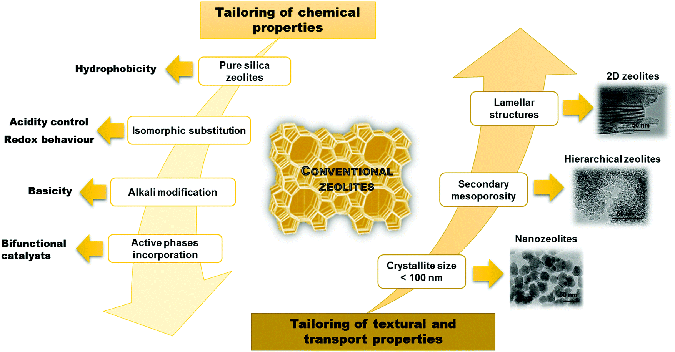

Figure 2.2: Zeolites varieties [29]

Recent technologies have been proposed: gasification of plastic wastes to produce synthesis gas, but it is very expensive and involves the construction of a facility dedicate to such process. To be successful, it crucially important to constructs number of big plantations. In this regard, catalytic cracking technologies for transportation fuels (gasoline, diesel) and chemicals are becoming more versatile and attracting more interest, as the viability of these technologies increases significantly as crude oil prices rise[14].

In regards of catalytic cracking technologies scientist improved natural method of silicate catalysts. Since 1960, zeolites have been used as catalysts. They are classified as hydrated aluminosilicates because they are made up of three-dimensional networks of SiO4 and AlO4 tetrahedra connected by mutual oxygen atoms. Zeolites are formed by an ordered structure.

Thermal and mechanical reliability of zeolites are proven to be excellent. Furthermore, zeolites have a uniform microporous structure (diameters around 2 nm) that provides shape selectivity by placing a size-exclusion limit on molecules entering and leaving the zeolite channels. Zeolites are widely used as form-selective adsorbents and catalysts in a variety of industries due to their unusual uniformity and shape selectivity [15].

**2.2.1.2. MECHANISM OF REACTION**

The applied process of degradation of polymer will have a big impact on how it degrades: heat (thermal degradation), heat and catalyst (thermo catalytic degradation), oxygen (oxidative degradation), heat and oxygen (thermo-oxidative degradation), radiation (photochemical degradation), radiation and catalyst (thermo catalytic degradation), and radiation and heat (thermo-oxidative degradation) [16].

The degradation mechanisms may have an impact on the yield, form, and size of the commodity. Unzipping, for instance, improves monomer efficiency, and chain contributes to linear scission, but cross-linking in a dynamic process continues to generate non-linear molecules and aromatics, as well as increasing the complexity of non-evaporable polyaromatics.

Photo-oxidative oxidation, organic degradation, and so forth. These techniques all have one thing in common: they induce permanent changes in the composition of polymers. The decomposition of a polymer's structure results of a reduction in molecular weight as well as major improvements in physical and chemical properties.

Thermal degradation and thermo catalytic degradation, also known as chemical recovery in the literature, are well-known and well-studied processes. Chemical processing and chemical decay are not the same thing since chemical degradation is the result of a chemical reaction.

Material oxidation (acids, solvents, alkalis, and so on) is what this term refers to. The thermal and catalytic cracking of waste polymers has been mentioned in several publications. Polyethylene and polypropylene are two kinds of polymers that have received a lot of attention because they account for 60–65 percent of all plastic waste.

Catalysts may be used to change the structure of the hydrocarbons formed. Catalytic cracking uses less energy than non-catalytic cracking and helps in the creation of new materials of More hydrocarbons with branching chains. Addition of catalyst, on the other hand, may be problematic, since the catalyst accumulates in the residual or coke. The melted polymer and catalysts can be contacted in two ways: either the polymer and catalyst are combined first, then melted, or the molten plastics are fed continuously over a fluidized catalyst bed [17].

US-Y and HZSM-5 are the most commonly used catalysts. The HZSM-5 and FCC catalysts were found to have the highest chances of yielding hydrocarbons in the boiling range of gasoline.

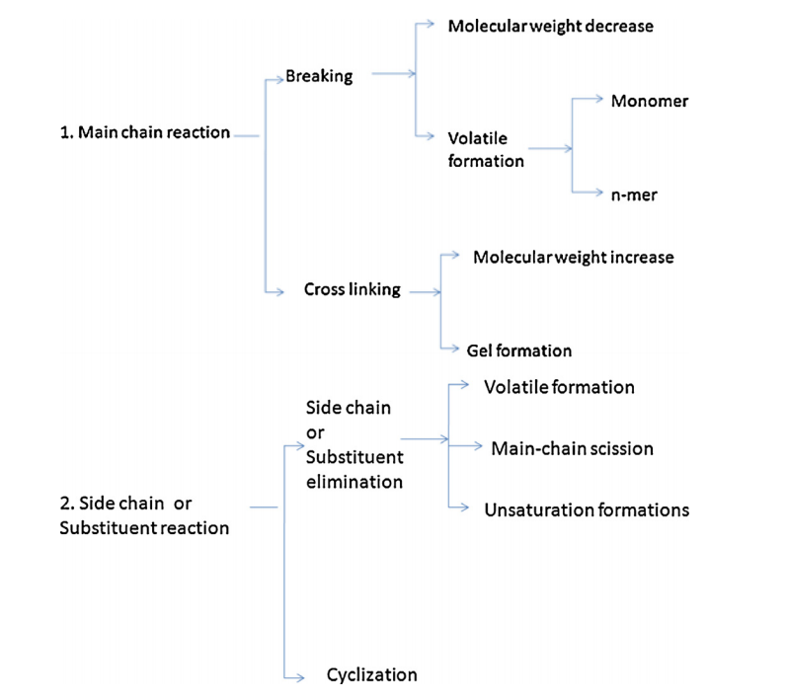

Figure (2.3): Mechanism

US-Y and HZSM-5 are the most commonly used catalysts. The HZSM-5 and FCC catalysts were found to have the highest chances of yielding hydrocarbons in the boiling range of gasoline.

Chemical recovery is accomplished by solvolysis or pyrolysis, with solvolysis involving the deterioration of materials by solvents, such as water, and pyrolysis involving the degradation of materials by heat in the absence of oxygen or air, or vacuum. Monomers, petroleum fuels, and gases are generated by chemical recycling. Distillation and drying purify monomers, which are then used to make polymers . On a commercial scale, chemical recycling processes for PET were applied almost simultaneously with the polymer's manufacture [18].

Figure (2.4): Hierarchical zeolite production methods from microporous zeolites

**2.2.1.3. HYDROCRACKING AND OTHER METHODS**

Since polyolefins make up a large portion of post-consumer plastic waste (typically 65 percent or more, according to Plastics Europe, 2007), the initial emphasis was on hydrocracking HDPE with 1 wt. percent Pt-loaded USY catalysts with a Si/AlF ratio of 9.0. Centered solely on carbon content, products were classified into three fractions [19]: organic gasses (Carbon length between 1-4), oil types (C5 - C12), and diesel (D1 - D12) (C13 - C20).The amount of coke produced on the catalyst was calculated by researchers as a percentage of the total carbon on the catalyst[20].

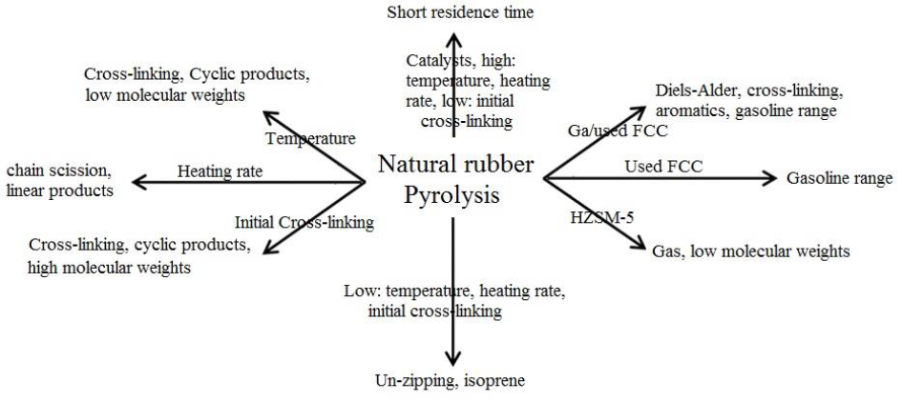

Figure (2.5) Pyrolysis process of natural rubber and end products of these processes

CO2 has been used to catalyze the transition of organic functional groups and as a pyrolysis medium to boost biomass pyrolysis gas production (e.g., CO) CO2 has been used as well cellulose hydrolysis [21], for example, is a form of biomass pretreatment. When CO2 is present in the presence of water, it may become acidic. As a result, existing efforts are focused on pretreating raw biomass prior to enzymatic hydrolysis in order to increase lignocellulose accessible surface area and enhance biomass digestibility [22] at the stage of digestion. Enzymatic hydrolysis is a form of enzymatic hydrolysis. Increased surface area and digestibility aid in the degradation of cellulose and/or lignin, resulting in higher yields of hydrolysis materials such as glucose and xylose.

When a good catalyst, polymer, and reacting gas are mixed properly, both the reaction time and the necessary reaction temperature can be drastically reduced. Temperature is rising with increasing volumes of petrol, improved lighter commodity yield (table)[23,24]

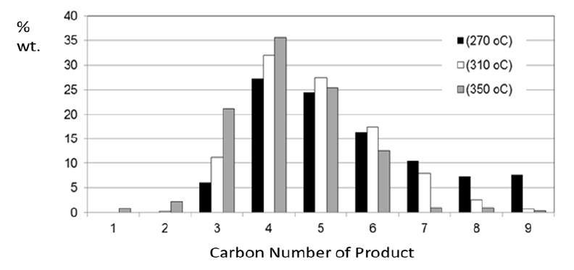

To prevent coking and subsequent catalyst deactivation, the results indicate that a high  pressure was needed.

|  |  |  |  |  |  |
| --- | --- | --- | --- | --- | --- |
| T (°C) | 350 | 310 | 270 | 270 | 270 |
| initial P (MPa) | 5.5 | 5.5 | 5.5 | 3.5 | 1.5 |
| Gas | 58.9 | 43.5 | 33.4 | 35.2 | 12.0 |
| Gasoline | 40.8 | 56.0 | 65.9 | 63.7 | 23.4 |
| Diesel | 0.0 | 0.0 | 0.3 | 0.2 | 0.2 |
| Coke | 3.9 | 4.9 | 5.0 | 8.8 | 17.4 |
| Conversion (wt.%) | 99 | 99 | 98 | 99 | 36 |

Table 2.1: Product distribution as a function of T and H2, pressure using HDPE with 1 wt. % Pt/USY

**2.2.1.4. FUTURE REACTOR DESIGNS**

For depolymerization of plastic waste, reactor selection is critical. A fluidized bed reactor, for example, has a shorter reaction residence time, which reduces secondary reactions and side product formation. Usually, a reactor with a longer residence period, such as a screw kiln, will be used for the manufacture of fuels and aromatics[25]

**2.2.1.4.1. CONICAL SPOUTED BED REACTOR**

The CSBR has a straightforward nature (essential for lowering investment costs associated with industrial or recycling treatments) and is particularly well suited to the pyrolysis of waste plastics due to the lack of segregation issues (due to the cyclic movement of the rigid, and therefore less defluidization issues than fluidized beds). Furthermore, the heat transfer rate is higher than in fluidised beds with heat transfer coefficients of 170 and 220 W m2 for wall-to-bed and bed-to-particle, respectively, compared to non fluidised beds[26].

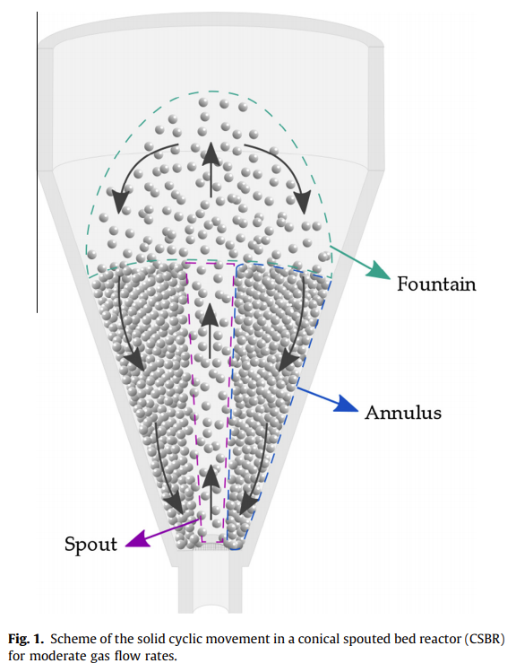

Figure (2.6): Schematic representation of CSBR workings

**2.2.1.4.2 BATCH AND SEMI-BATCH REACTOR**

When the reaction is being carried out, a batch reactor is essentially a closed structure with no inflow or outflow of reactants or materials. One of the ways to achieve high conversion in a batch reactor is to leave the reactant in the reactor for a long time. That is main benefit of this process. The inconsistency of the output from batch to batch, high labor costs per batch, and complexity of large-scale manufacturing are all drawbacks of batch reactors[27].

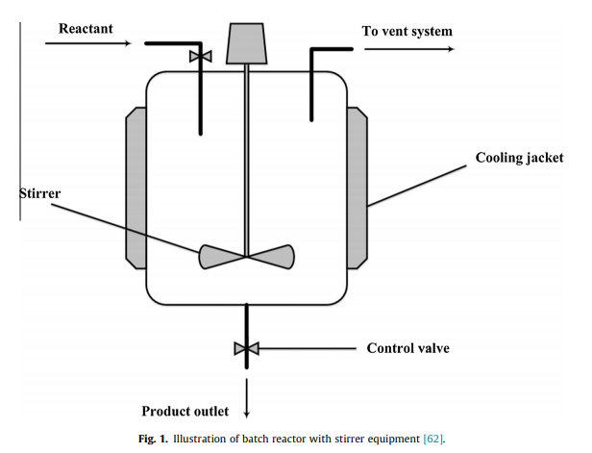

Figure (2.7): Schematic representation of batch reactor

**2.2.1.4.3 FIXED AND FLUIDIZED BED REACTOR**

As seen in Fig. (2.6), the catalyst in a fixed-bed reactor is usually palletized and packed in a static bed. It is simple to build, but there are some limitations, such as the unusual particle size and form of plastics used as feedstock, which could create difficulties during the feeding process. Furthermore, the reaction's access to the available surface area of the catalyst is restricted. However, some studies preferred to conduct plastic pyrolysis using a fixed-bed reactor. Fixed-bed reactors are only used as secondary pyrolysis reactors in some cases so the main pyrolysis product can be quickly fed into the fixed-bed reactor, which is usually made up of liquid anhydride[27].

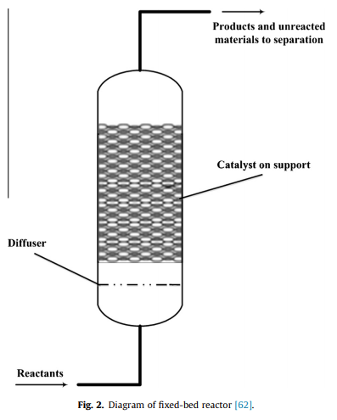

Figure (2.8): Schematic representation of fixed bed reactor

However, some studies have chosen to use a fixed-bed reactor for plastic pyrolysis. Since the output from primary pyrolysis can be quickly fed into the fixed-bed reactor, which usually consists of liquid and gaseous phases, fixed-bed reactors are only used as secondary pyrolysis reactors under certain circumstances.

**2.2.2. GASIFICATION**

Gasification of waste plastics converts plastics into syngas without igniting them. The product of the process differs the process from other processes such as incineration. The temperature of process approximately between 700-1500 °C. Gasifying agents are pure oxygen, steam, air. Air as gasifying agent is cost lesser than other agents and creating a significant amount of  in syngas. Oxygen as gasifying agent is a higher calorific value and creating cleaner syngas than air. Steam as gasifying agent is improving syngas quality, heating temperature value and creating significant amount of  and CO. [68,69,70,71,72,73,74]

Syngas is contained carbon dioxide (CO2), methane (CH4), carbon monoxide (CO) and hydrogen mixture (CO:H2) or nitrogen and hydrogen mixture (N2:H2). The quality of syngas highly depends on /CO ratio. Products of syngas are electricity, hydrogen, ethanol, diesel, renewable natural gas, fatty acids. Ethanol is used as fuel while it combined with gasoline. This combination releases carbon dioxide and water. Therefore, it makes it environmentally friendly. Hydrogen can be used as fuel while spent in the fuel cells. Hydrogen releases water. Transportation and electric applications are main usage for hydrogen fuels. .[68,69,70,71,72,73,74]

Gasification process parameters influence the content of syngas generated from plastic waste. Gasifying medium, type of gasifier, gas flow rate, feed flow rate, temperature and pressure, and features of feedstock are just a few of the parameters. The process parameters are chosen according to the desired product gas composition and applications. .[68,69,70,71,72,73,74]

**2.2.2.1. DIFFERENT PLASTIC WASTE FOR GASIFICATION**

Polyethylene (PE), polypropylene (PP), polyvinyl chloride (PVC) can be recycled by gasification process. PE: Polyethylene is a thermoplastic polymer. Mostly classified by mechanical features such as crystal structure, MW (molecular weight), variety of branching (Figure 2.7), or physical features. High density polyethylene (HDPE) has low branching, therefore, higher tensile strength and intermolecular forces. In contrast, low density polyethylene (LDPE) have high branching, lower tensile strength and intermolecular forces. PE mostly used in packaging.

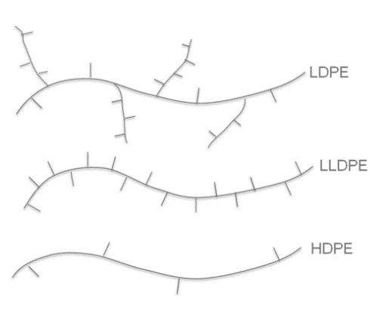

Figure 2.9: Branching of LDPE and HDPE[65]

PP: Polypropylene is thermoplastic polymer. PP have three types because of the location of methyl groups. These are isotactic, atactic, and syndiotactic (Figure 2.8). PP has similar properties with polyethylene. However, PP have lower density, more tough. PP mostly used in the automotive industry, textile, food packaging.

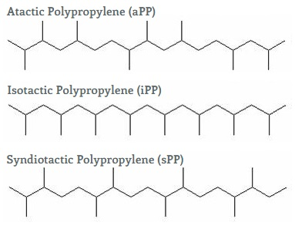

Figure 2.10 : types of PP[66]

PVC: Polyvinyl chloride (Figure 2.9) used two different types which is tough and flexible. PVC, which is originally tough plastic, can be more flexible by adding plasticizers. Tough type PVC used in pipes, constructions.

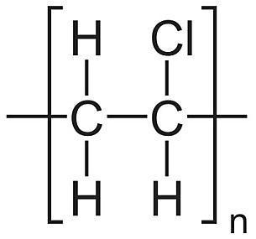

Figure 2.11: structure of PVC[67]

**2.2.2.2. REMOVING UNWANTED GASES FROM GASIFICATION PROCESS**

For many applications of syngas, the removal of organic (tar) and inorganic impurities such as H2S, HCl, NH3, HCN, alkali metals, and particulates should be investigated. For example, when, a large amount of organic generated during gasification and then cooled and condensed, causes fouling issues in the process equipment as well as damage to end-use devices such as fuel cell, gas engines and turbines. To reduce tar content in syngas, materials like alkali metal catalysts, calcium-rich additives (calcite, quicklime, dolomite), carbon-supported catalysts, and Ni-based catalysts have been commonly used as catalysts. HCl generated during the gasification of PVC plastic wastes can cause severe corrosion issues in equipment as well as poisoning effects on tar cracking catalysts. To reduce the HCl content in producer gas, CaO-based sorbents such as quicklime (CaO) and calcined dolomites (CaO.MgO) have been used in the gasification of plastic waste. [68,69,70,71,72,73,74]

**2.2.2.3. GASIFICATION PROCESS**

According to experiment of research, PP and PE can be placed in gasifier and for this research schematic design (Figure 2.10) made by Aspen Plus simulator. In gasifier, plastic waste and steam which is gasifying agent, reacted together. Gasifiers have two sections which is decomposition of plastic waste (DECOMP) and reaction of plastic waste with gasifying agent (GASIFIER). Before, reacting with gasifying agent, plastic waste must be disintegrated. Because it would be more convenient for reaction. As seen schema below (figure x), firstly, plastic waste (PLASTİC) is heated by heater (HEATER 1). Then plastic waste went to decomposition unit (DECOMP). Steam made from heating water (WATER) by heater ((HEATER 2)). Decomposed plastic waste went to gasifier (DE-PLA) while steam also went to gasifier (STEAM) at same time. The gas product (PRODUCT) can be produced once the chemical reactions have been completed in the gasifier. The specifications of each unit model in the gasification of plastic waste are described in Figure 2.11.[70]

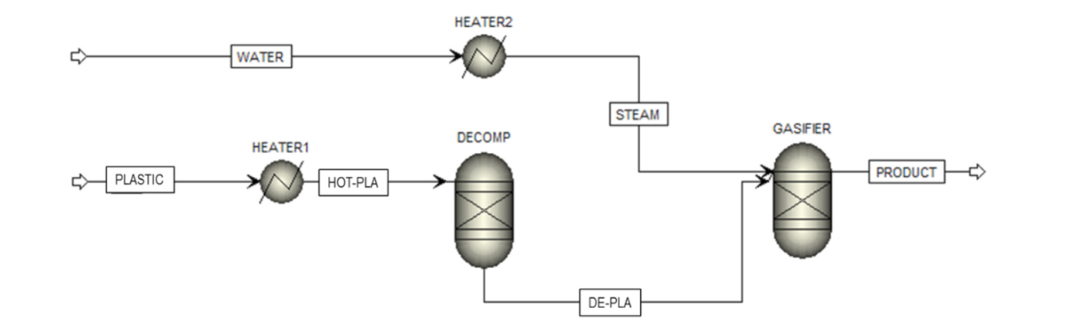

Figure 2.12 : Gasification process of plastic waste[70]

metin içeren bir resim

Açıklama otomatik olarak oluşturuldu

Table 2.2 [70]

The possible reactions in gasifier :[70]

Boudouard Reaction



Water-gas Reaction



Hydrogasification



Water-gas shift Reaction



Methanation Reaction







Reforming Reaction



**2.2.2.4. TWO-STAGE GASIFICATION PROCESS**

The two-stage gasifier, unlike other gasifiers, has the advantage of allowing several additives to be added within the gasifier for impurity removal.[72]

A feeding system, a two-stage gasifier, a char removal system, a quenching system, and an EP (electrostatic precipitator) are all part of the gasification system (Figure 2.11). The feeding mechanisms have two screw feeder types. These are upper and lower screw feeders. The feeding rate was regulated by the upper screw feeder. The feeding rate was regulated by the upper screw feeder. The lower feeder, which was installed with a water jacket, rotated as quickly as possible to help unload the feed material evenly. Two-stage gasifiers have a bubbling fluidized bed (lower reactor) and a tar-cracking zone (upper reactor). [72]

According to the results of research, the fluidizing gas, air, was heated to 450 °C using a pre-heater and then inserted into the lower reactor using a bubble-cap style distributor plate in the gasification experiments. In the lower reactor, the main gasification reactions took place. The syngas escaped from the lower reactor and entered the upper reactor's additive bed, where reactions, especially tar-cracking reactions, took place, through a distributor. The syngas that escaped the upper reactor went through the char removal and quenching systems before arriving at the EP.[72]

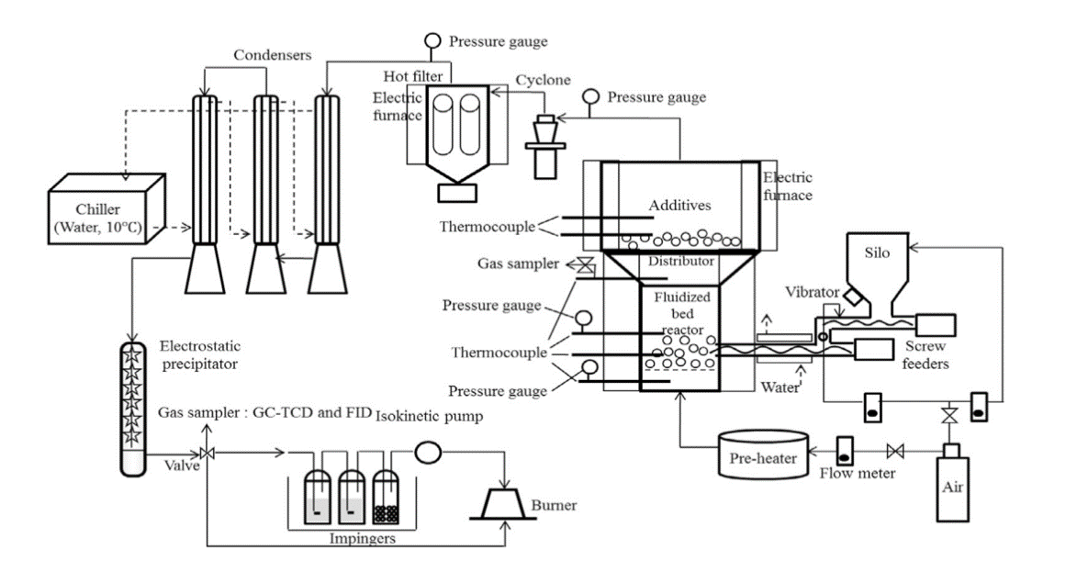

Figure 2.13 : Two -stage gasification process[72]

**2.3. SOLVOLYSIS**

Solvolysis is theoretically a more specialized and selective method of recovering monomers from polyesters and polyamides unlike pyrolysis since it uses lower temperatures for reaction. Hydrolysis, alcoholysis, glycolysis and aminolysis are commonly used solvolysis processes. Since ether, ester and acid amide bonds are broken-down by these processes, they are exclusively used for polymers with such bonds. PET [89-93] and PU [94-95] depolymerization with solvolysis methods have more studies conducted on them. The benefit of these methods is the ability to produce monomers that can be further refined by filtering out contaminants and colorants, allowing for a virgin grade material.

Using these processes is important since some polymers are impossible to mechanically recycle such as PU. If the obtained monomer is not pure or consistent as the monomers originally used, end product can be combined with virgin grade monomers for synthesizing polymers.

There are a few industrial plants for PET methanolysis [96] and PET and PU glycolysis [97] High temperatures are needed for hydrolysis process to take place, therefore, high amounts of energy is needed. Increase in progression and preference of these processes are linked to the amount of energy that hydrolysis requires. [98, 99]

**2.3.1. HYDROLYSIS**

Hydrolysis process can be summarized as the breakdown of a molecule by reacting with an alkaline, acidic or enzymatic environment. Water or alcohol is clearly one of the reactants in the condensation polymerization plastics hydrolysis or alcoholysis reaction, and it is converted into the chemical molecules. Water was used to provide hydrogen during the depolymerization of polyethylene, making it not only a solvent but also a reactant.. In case of PET depolymerization into its monomers such as TPA and EG given the optimal conditions are met. Methanolysis, glycolysis, hydrolysis, supercritical methanolysis, and supercritical hydrolysis are the most common chemical processing processes for waste poly(ethylene terephthalate) (PET). The invention of a method for the hydrolytic depolymerization of PET, in which terephthalic acid (TPA) and ethylene glycol (EG) are recovered and can be used directly in the synthesis of virgin PET, has piqued interest.

**2.3.1.1. ALKALINE HYDROLYSIS**

The most popular solutions for alkaline hydrolysis are NaOH and KOH solutions with concentrations around 4-20%[100,101]. Output of hydrolysis process for PET is EG and TPA-Na2 or TPA-K2 depending on the type of solution. Recovery of EG is achieved by distilling the mixture. In order to obtain pure TPA as an end product, a strong acid is added to neutralize the NaOH or KOH in mixture

**2.3.1.2. ACID HYDROLYSIS**

Concentrated sulphuric acid, as well as other mineral acids such phosphoric or nitric acid, are used to perform acid hydrolysis. Figure 2.13 shows how PET hydrolysis works in a sulphuric acid (H2SO4) environment.

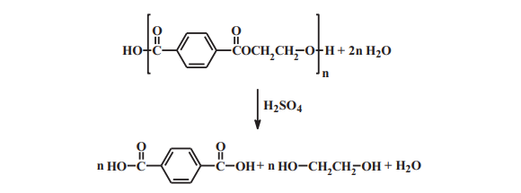

Figure (2.14): PET acid hydrolysis using sulphuric acid environment

.

Methods practiced in various researches show ways for collecting TPA from concentrated sulphuric acid preferably at 60 Degree Celsius. Researchers recovered EG from the final filtrate by extraction using trichloroethylene, therefore an organic solvent. Another way of processing TPA requires a reaction of 90 percent sulphuric acid at 85 degrees Celsius. A reaction of condensed sulphuric acid was also carried out, albeit at room temperature. The high corrosiveness of the reaction mixture, as well as the considerable quantities of inorganic salts and polluted water released, are disadvantages of a PET hydrolysis reaction carried out in concentrated acids. A process that involves acid hydrolysis of diluted sulphuric acid followed by sulphuric acid recovery necessitates a much longer reaction time and a higher reaction temperature of 150°C.[ ]

**2.3.1.3. ENZYMATIC HYDROLYSIS**

Additional considerations must be considered when it comes to PET hydrolysis. At temperatures above the glass transition temperature, the polymer chain is expected to fluctuate (Tg). PET's Tg value is about 80 °C, although it is reduced in water due to water molecules. increasing chain mobility by diffusing between polymer chains

Various ester bond hydrolases hydrolyze aliphatic polyesters (natural and synthetic) at room temperature. Enzymatic hydrolysis of aliphatic-co-aromatic polyesters is difficult, but there are several possibilities.[103]

**2.3.2. GLYCOLYSIS**

Glycolysis is one of the most used and studied recycling process of PET. Prior studies suggest that glycolysis is currently the most important recycling process for PET since products obtained from this process such as unsaturated polyester resin, epoxy resins, alkyd resins [104], are commercially valuable and can be directly used in production lines. Recent research papers suggest that glycolysis can be used commercially for recycling of other polymers such as Polyurethane.[106]

Glycolysis is the degradation of PET using glycols and trans-esterification catalysts such as different metal acetates. This type of reactions are being used in chemical recycling since 1965[107] Basic mechanism of this process is breaking down of ester bonds in polymer and hydroxyls take their place. This process is usually seen used for large scale recycling operations. Previous studies suggest that glycolysis process requires presence of a catalyst otherwise total breakdown process of PET cannot be completed and is very slow. [105]

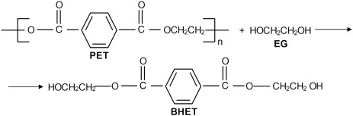

Figure ( 2.15) : Glycolysis of PET

Ethylene glycol (EG) is the most widely used glycol in glycolysis of PET. The oldest, easiest, and least capital-intensive method is glycolysis with EG as a depolymerization solvent. Bis(2-hydroxyethyl) terephthalate (BHET) is the main product of the reaction, particularly when large amounts of EG are used, as well as other ethylene terephthalate oligomers obtained through transesterification. During depolymerization of PET, two reversable processes occurred: glycolysis of PET reaching equilibrium with (polycondensation) and BHET transformation from monomer to dimer.

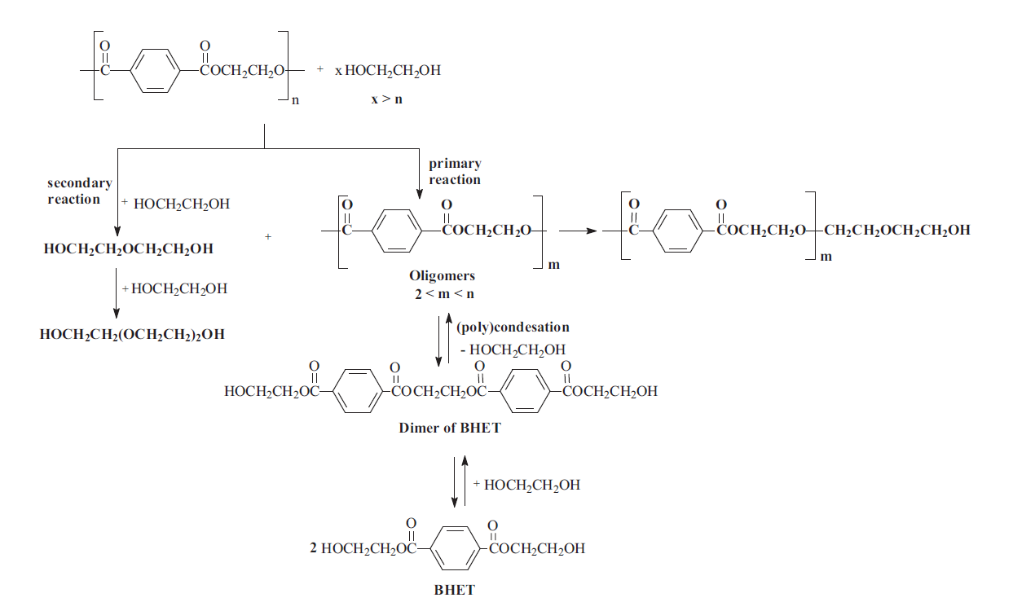

Figure (2. 16): Glycolysis process of depolymerization of PET with EG [105]

**2.3.3. ALCOHOLYSIS**

Alcoholysis is a trans-esterification reaction that uses alcohols as a catalyst. One of the most commonly depolymerized polymers using alcoholysis is PET. PET alcoholysis of 2-ethylhexanol (2-EH) yields dioctyl terephthalate, a plasticizer with excellent properties. This procedure can be carried out at a temperature of reflux [108]. At atmospheric pressure, the boiling temperature of 2-EH is about 180°C, and the performance of alcoholysis in these conditions is very low. It was carried out using subcritical and supercritical 2-EH to increase the performance of the operation[109]. This approach shows successful results, but it has the disadvantage of requiring the use of high-pressure reactors.

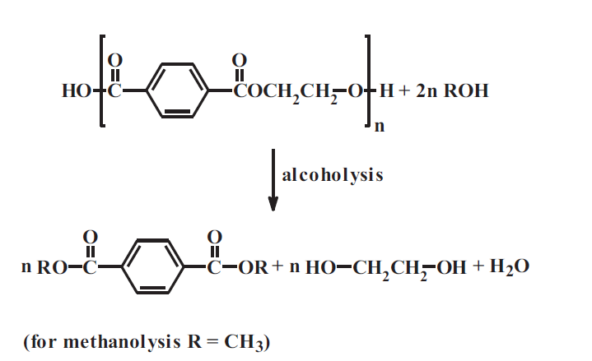

Figure (2. 17): Schematical representation of alcoholysis.[105]

The inclusion of a cosolvent, which alters the dissolution properties of 2-EH and thereby increases the performance of the process [109], is another way to speed up the alcoholysis process. Water can be used as a cosolvent, which improves the efficacy of the alcoholysis of vegetable oil greatly.

Alcoholysis has the advantage of being able to spot the process installation on the manufacturing line. Due to its high purity, DMT can be used directly in processing. EG and methanol can also be recycled and reused with ease. In this case, the waste produced during the PET manufacturing process can be directly converted to the alcoholysis process and used to create the polymer. The high cost of isolation and purification of the reaction products being produced (glycols, alcohols, and phthalate derivatives) [110] is a downside.

**2.3.4. AMINOLYSIS**

Aminolysis is the process of breaking down of a molecule by a reaction with an amine. Comparing aminolysis with other processes for example glycolysis, uses glycols to produce amines, while aminolysis consumes amines.[116] Studies on chemical recycling of polymers using aminolysis process is rather limited compared to other methods used.[113] Most commonly aminolysis process is used in recycling of PET and fairly new studies on recycling of PU foams and PS. Looking into recycling of PET, aminolysis process, for PET is the reaction with amines.

PET depolymerization can be achieved with amines including polyamides, morpholine, hydrazine and allylamine[110-111-112]. At 170°C and 2 MPa, waste PET reacts with excess allylamine to create N,N'-bis allyl terephthalamide. This substance has a melting point between 217-219°C and can be used to cross-link unsaturated polyester resins at high temperatures. TPA and EG diamides can be obtained as a result of PET aminolysis. In a solution of hydrazine, benzyl amine, ethylene diamine, hexamethylene diamine, piperidine, and aniline, this reaction can be carried out. However, this method is yet to be used on a large scale.[114]

Using triethanolamine as a degradant, corresponding ester products are obtained. Reaction products can serve as potential raw materials for the synthesis of polyurethanes, especially rigid polyurethane foams, due to the existence of hydroxyl and amine functional groups.[115]

Aminolysis process is also seen in depolymerization and recycling of PU more specifically PUF. Research suggests that polyester-based PUs depolymerize rather faster than polyether-based PUs.

**2.4. DISSOLUTION**

Dissolution/precipitation removes additives such as pigments from that are embedded in the structure of polymer in its production process. Additives like flame retardants can also be recycled. Dissolution/precipitation processes may extract one polymer from a mixture of polymers, such as those used in multilayer films, such as PP/PA or PP/PET, or from plastics found in waste electric and electronic equipment (WEEE).

Dissolution/precipitation does not strictly belong in a specific chemical recycling mechanism since no bonds are normally cleaved. Despite that, since understanding the solvent/polymer relationship, solvent design, and solvent recovery require fundamental chemical knowledge, this process is covered in this perspective and is often referred to as chemical recycling.

A solvent/non-solvent method is used to isolate and reprocess. The selected plastics can be separated using a combination of solvents and dissolution/precipitation steps. The solubility of a polymer depends on temperature, therefore; variety temperature must be investigated for it. Non-dissolved materials such as pigments can be isolated from the polymer solution by filtration which is in between the dissolution and precipitation stages. (Figure 2.16) Chosen solvents should be easily evaporate, not toxic, greatly dissolve desired polymer and not dissolve additives. Xylene, toluene, acetone is some of the solvents that chosen for solvent/anti solvent system even though they are toxic.

Dissolution/precipitation method have many limitations. When the process is finished, solvent and anti-solvent should be separated for using again for the process. It would be energy and time consuming if solvent have high boiling temperature. However, if supercritical fluid is one of the selected solvents, solvent can evaporate by decreasing pressure. For example, as solvent and antisolvent system can be formic acid, dimethyl ether and  as supercritical fluid. However, many polymers cannot be dissolved in supercritical fluid. Therefore, super critical fluid used for extract additives like flame retardant, pigment, dyes, stabilizers. .[75,76,79]

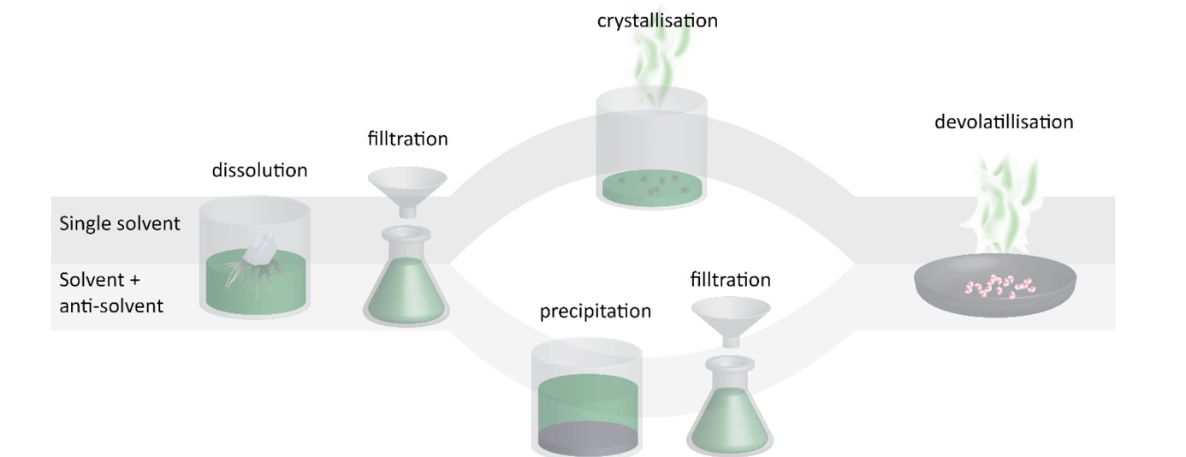

Figure 2.18: Process of Dissolution/precipitation

**2.5 PIGMENTS**

The key reason for using pigments in plastics is to add color, either for aesthetic or practical reasons. Pigments are often used for purposes such as optical function (opaque, transparent), mechanical strengthening or, the prevention of polymer degradation. Pigments are classified as inorganic pigment and organic pigment. [80]

**2.5.1. INORGANIC PIGMENT**

Since prehistoric times, natural inorganic pigments such as iron oxides derived from mineral sources have been used as colorants. Inorganic pigments have many advantages for plastics. Because they have great resistance to heat and chemicals. In addition, the cost of inorganic pigments is affordable and they give plastics various technical advantage. However, for the aesthetic aspect, the color of an inorganic pigments is not as bright as color of an organic pigment. They are usually opaque. Inorganic pigments classified as white pigments, black pigments, colored inorganic pigments. Examples for such pigments are; Titanium dioxide (Titanium dioxide is a white opaque pigment and most common inorganic pigment), Black pigment (Black pigments are made from carbon. Carbon black is common and used for printing) and more. [80]

**2.5.2. ORGANIC PIGMENTS**

Organic pigments are known for their high color intensity and brightness, as well as their transparency. Organic pigments are classified as polycyclic pigments, azo pigments, and metal complexes. The quality of pigments depends on their chemical structures, crystallinity.

Copper phthalocyanines (Figure 2.17) are the most important organic pigment. Its brilliant blue color, resistance to light, heat, acids, and alkalis make it a popular choice for most plastic applications. Furthermore, despite its structural complexity, copper phthalocyanine is an inexpensive pigment because it is being produced in large quantities from low-cost starting materials. [80]

bal peteği, atletik oyun, futbol içeren bir resim

Açıklama otomatik olarak oluşturuldu

Figure 2.19: Copper phthalocyanines

Azo pigments are a shade of yellow, orange, and red. Azo colorants are described as compounds that contain one or more azo (-N=N-) groups. [80]

**2.6. FLAME RETARDANTS**

Flame retardants (FRs) are added plastics to prevent them from igniting easily making them more ignition resistant. FRs are commonly used for electronic devices for fire safety codes. Brominated flame retardants (BFR) are a common flame retardant type. However, a downside of using BFRs is that they are persistent, bio-accumulative, and toxic. The BFRs in e-waste plastics will generate brominated aromatic compounds at heat treatments. Mechanical recycling needs low degree impurity for waste plastics. Therefore, electronic devices cannot be recycled by mechanical recycling. With traditional extraction using organic solvents, high BFR extraction efficiencies on e-waste plastics can be achieved. Organic solvents used in the solvent extraction process are toluene, methanol, isopropanol, 1-propanol, acetonitrile, and ethanol. Solvents should be able to dissolve BFRs without dissolving plastics.[77]

1. **CONCLUSION**

Currently one of the greatest global problems is the recent increase in the accumulation of the plastic wastes contributing a substantial percentage of the landfill mass. Looking into the attempts that address this plastic waste problem, new methods for that are other than conventional mechanical (physical treatment) recycling, or energetic recycling (basically combusting plastic waste as a fuel) being developed in a great rate. Mechanical recycling is not a sustainable solution for plastic waste problem since the end products that are obtained from such processes are limited in their physical and chemical properties. Chemical recycling of polymers can address other problems than environmental. Another main topic is the increasing need for raw materials for plastic industry. However chemical recycling alone will not be able to solve both need for raw materials for production lines or plastic waste problem. Improvement on product designs and changing public mindset on usage of disposable plastic packaging and other products. Plastic recycling is mainly dependent on cleaning of the waste mass and this also is one of the most important limitations for chemical recycling. Immediate improvements on cleaning and sensory systems that are used in the sorting process is required to keep the whole recycling process time and cost efficient. Since every polymer requires a different recycling method and the obtained end products after these processes are different, some level of purity needs to be reached.

This review article is a general overview on the current chemical recycling methods that are being used commercially and are being studied and developed. For example, glycolysis of PET is thoroughly studied and is being used in commercial scale plantations, whereas depth and availability of studies on aminolysis of PET is significantly limited. In this article we have gathered information on chemical recycling processes under thermal routes such as pyrolysis and its variations, gasification and different types for different polymers, hydrolysis and it’s variations, glycolysis, alcoholysis, aminolysis and lastly dissolution/precipitation. In light of these information further improvement of these methods and technologies are required in order to improve the current rate of plastic recycling. Currently reaction systems have limitations for example, for pyrolysis if optimal conditions such as temperature or viscosity of polymer, catalyst and solvent mixture are not met, this can cause whole system shutdowns and decrease both lifetime of recycling system and cost-efficiency.

One of the most desired recycling methods, pyrolysis has shown great potential for mixed plastics processes as it produced common outputs from most used plastics as Polypropylene, Polyethylene, Polystyrene. Therefore, articles that are reviewed, informs about the potential of mass recycling of landfills as a number of mechanical issues solved. One of them was mentioned as viscous fluids. When it is failed to control viscosity during processes with alcoholic chemicals, it is possible to expect clogging through systems. Therefore, literature aimed towards improvement of catalysm mechanisms such as silicate crystals named as Zeolites.

Every method has its advantage and disadvantage as such while dissolution method is most desirable in terms of CO2 emissions, it’s disadvantage is that the solvents used in this process is highly hazardous. However recent technologies make the recovery of these solvent possible. Methods under solvolysis have the greatest monomer recover rate but this method is limited to recycling of polyesters and polyamides such as PET and PU. As for thermal methods like pyrolysis, it is reported that it has the greatest environmental impact among these processes. However, recent developments on catalyst and reactors designs can improve the monomer yield. Even though, pyrolysis has greater environmental impact, it is still has lower impact than conventional mechanical recycling methods.

In conclusion, current state of recycling methods is not remotely close to being sufficient for solving both plastic waste and raw material problems. Future studies are needed to further develop current methods, eliminate their limitations, and discover new and greener methods. However, this alone is not going to be satisfy the global needs. Government and corporations’ policies are required to be improved on usage of plastics and designing of plastic products.

1. **REFERENCES**

[1]- DEFINITIONS OF TERMS RELATING TO THE STRUCTURE AND PROCESSING OF SOLS, GELS, NETWORKS, AND INORGANIC–ORGANIC HYBRID MATERIALS (IUPAC Recommendations 2007) Prepared by a working group consisting of J. ALEMÁN1, A. V. CHADWICK2, J. HE3, M. HESS4, K. HORIE5, R. G. JONES2, P. KRATOCHVÍL6, I. MEISEL7, I. MITA8, G. MOAD9, S. PENCZEK10, AND R. F. T. STEPTO11 10.1351/pac200779101801

[2]- Angew. Chem. Int. Ed. 10.1002/anie.201915651 Angew. Chem. 10.1002/ange.201915651

[3]-B. K. Sharma, B. R. Moser, K. E. Vermillion, K. M. Doll, N. Rajagopalan, *Fuel Process. Technol.* **2014**, *122*, 79–90.

[4] B. K. Sharma, B. R. Moser, K. E. Vermillion, K. M. Doll, N. Rajagopalan, *Fuel Process. Technol.* **2014**, *122*, 79–90.

[5] F. J. Mastral, E. Esperanza, P. García, M. Juste, *Pyrolysis of High-Density Polyethylene in a Fluidised Bed Reactor. Influence of the Temperature and Residence Time*, **2002**.

[6] S. Kim, *Waste Manag.* **2001**, *21*, 609–616.

[7] P. Prawisudha, T. Namioka, L. Liang, K. Yoshikawa, *J. Environ. Sci. Eng.* **2011**, *5*, 432–439.

[8] P. J. de Wild, H. den Uil, J. H. Reith, J. H. A. Kiel, H. J. Heeres, *J. Anal. Appl. Pyrolysis* **2009**, *85*,124–133.

[9] M. Artetxe, G. Lopez, M. Amutio, G. Elordi, J. Bilbao, M. Olazar, *Chem. Eng. J.* **2012**, *207*–*208*,27–34.

[10] R. R. Guddeti, R. Knight, E. D. Grossmann, *Ind. Eng. Chem. Res.* **2000**, *39*, 1171–1176.

[11] W. Kaminsky, in *Macromol. Symp.*, Wiley-VCH Verlag, **2016**, pp. 10–22.

[12] T. Yoshioka, G. Grause, C. Eger, W. Kaminsky, A. Okuwaki, *Polym. Degrad. Stab.* **2004**, *86*, 499–504.

[13] D. P. Serrano, J. Aguado, J. M. Escola, *ACS Catal.* **2012**, *2*, 1924–1941.

[14] G. Celik, R. M. Kennedy, R. A. Hackler, M. Ferrandon, A. Tennakoon, S. Patnaik, A. M. LaPointe,

S. C. Ammal, A. Heyden, F. A. Perras, et al., *ACS Cent. Sci.* **2019**, *5*, 1795–1803.

[15] D. P. Serrano, J. Aguado, J. M. Escola, J. M. Rodríguez, in *Stud. Surf. Sci. Catal.*, **2002**, pp. 77–84.

[16] S. Kumar, A. K. Panda, R. K. Singh, *Resour. Conserv. Recycl.* **2011**, *55*, 893–910.

[17] A. M. Al-Sabagh, F. Z. Yehia, G. Eshaq, A. M. Rabie, A. E. ElMetwally, *Egypt. J. Pet.* **2016**, *25*, 53–64.

[18] T. Ueno, E. Nakashima, K. Takeda, *Polym. Degrad. Stab.* **2010**, *95*, 1862–1869.

[19] W. Ding, J. Liang, L. L. Anderson, *Energy and Fuels* **1997**, *11*, 1219–1223.

[20] M. S. Abbas-Abadi, M. N. Haghighi, H. Yeganeh, A. G. McDonald, *J. Anal. Appl. Pyrolysis* **2014**, *109*, 272–277.

[21] E. E. Kwon, S. Kim, J. Lee, *J. CO2 Util.* **2019**, *31*, 173–180.

[22] T. Lee, J. Lee, Y. S. Ok, J. I. Oh, S. R. Lee, J. Rinklebe, E. E. Kwon, *J. Clean. Prod.* **2017**, *162*, 1465–1471.

[23] J. Lee, T. Lee, Y. F. Tsang, J. I. Oh, E. E. Kwon, *Energy Convers. Manag.* **2017**, *148*, 456–460.

[24] A. Akah, J. Hernandez-Martinez, C. Rallan, A. A. Garforth, *Chem. Eng. Trans.* **2015**, *43*, 2395–2400.

[25] I. Barbarias, M. Olazar, G. Lopez, J. Bilbao, M. Amutio, M. Artetxe, R. Aguado, A. Arregi, *Waste*

[26] R. W. Ashcraft, G. J. Heynderickx, G. B. Marin, *Chem. Eng. J.* **2012**, *207*–*208*, 195–208.

[27] S. D. Anuar Sharuddin, F. Abnisa, W. M. A. Wan Daud, M. K. Aroua, *Energy Convers. Manag.* **2016**, *115*, 308–326.

[28]"Process Flow Diagram of a classical" https://www.researchgate.net/figure/Process-Flow-Diagram-of-a-classical-pyrolysis-plant-with-a-novel-vortex-reactor-technology_fig25_319189954 access date 24/04/21

[29] "Tailoring of chemical properties" https://pubs.rsc.org/en/content/articlelanding/2018/cs/c8cs00370j#!divAbstract access date 24/04/21

[30] <https://journals.openedition.org/factsreports/5102>

[31]  ["How Big Oil Misled The Public Into Believing Plastic Would Be Recycled"](https://www.npr.org/2020/09/11/897692090/how-big-oil-misled-the-public-into-believing-plastic-would-be-recycled). NPR.org. Retrieved 2020-12-18.

[32]  ["How Big Oil Misled The Public Into Believing Plastic Would Be Recycled"](https://www.npr.org/2020/09/11/897692090/how-big-oil-misled-the-public-into-believing-plastic-would-be-recycled). NPR.org. Retrieved 2020-12-19*.* [33]  ["Global markets and material price updates"](https://www.complydirect.com/news/global-markets-and-material-price-updates/). complydirect.com. Retrieved 1 May 2020.

[34]  "the amount of recycled plastics is relatively small—3.0 million tons for a 8.4 percent recycling rate in 2017" , United States Environmental Protection Agency ,2020-10-25

[35]  [*"Piling Up: How China's Ban on Importing Waste Has Stalled Global Recycling"*](https://e360.yale.edu/features/piling-up-how-chinas-ban-on-importing-waste-has-stalled-global-recycling)*. Yale E360. Retrieved 2020-10-12.*

[36] PBS, Frontline, 31 March 2020, ["Plastics Industry Insiders Reveal the Truth About Recycling"](https://www.pbs.org/wgbh/frontline/article/plastics-industry-insiders-reveal-the-truth-about-recycling/)

[37] National Public Radio, 12 September 2020 ["How Big Oil Misled The Public Into Believing Plastic Would Be Recycled"](https://www.npr.org/2020/09/11/897692090/how-big-oil-misled-the-public-into-believing-plastic-would-be-recycled)

[38]  [*"Piling Up: How China's Ban on Importing Waste Has Stalled Global Recycling"*](https://e360.yale.edu/features/piling-up-how-chinas-ban-on-importing-waste-has-stalled-global-recycling)*. Yale E360. Retrieved 2020-10-12*

[39] Raju Francis, Recycling of Polymers, 2016

[40]  [*"These Companies Are Trying to Reinvent Recycling"*](https://www.bloomberg.com/news/articles/2019-04-09/-unmaking-plastics-spurs-120-billion-potential-market-in-trash). www.bloomberg.com*. Retrieved 2019-09-05*.

[41]  *Siegel, R. P. (2019-08-07).*[*"Eastman advances two chemical recycling options"*](https://www.greenbiz.com/article/eastman-advances-two-chemical-recycling-options)*. GreenBiz. Retrieved 2019-08-29.*[42]  [*"Commercial plastics-to-fuel plant receives financing"*](https://resource-recycling.com/plastics/2019/04/17/commercial-plastics-to-fuel-plant-receives-financing/)*. Plastics Recycling Update. 2019-04-17. Retrieved 2019-09-05.*

[43] Onur Dogu, Matteo Pelucchi , Ruben Van de Vijver , Paul H.M. Van Steenberge , Dagmar R. D’hooge, Alberto Cuoci , Marco Mehl , Alessio Frassoldati , Tiziano Faravelli, Kevin M. Van Geem, The chemistry of chemical recycling of solid plastic waste via pyrolysis and gasification: State-of-the-art, challenges, and future directions

[44]code of plastics, <https://www.spg-pack.com/blog/wp-content/uploads/2018/06/post-shutterstock_197759183-1024x683.jpg>, 04.20.2021

[45] https://images.theconversation.com/files/269646/original/file-20190416-147514-1573sta.jpg?ixlib=rb-1.1.0&q=45&auto=format&w=496&fit=clip, 04.20.2021

[46] https://i1.wp.com/bioplasticsnews.com/wp-content/uploads/2021/03/plastic-incineration.jpeg?resize=2000%2C1200&ssl=1, 04.20.2021

[47] https://news.bio-based.eu/media/2020/11/Plastic-recycling-and-recovery-routes.png, 04.20.2021

[48] <http://www.circulareconomyasia.org/wp-content/uploads/2019/12/xMechanical-recycling.png.pagespeed.ic.zavuf2Bt5C.png>, 04.20.2021

[49] https://epsco.ir/wp-content/uploads/2018/11/pet_907px.jpg, 04.20.2021

[50] https://epsco.ir/wp-content/uploads/2019/10/PVC-Pipes.jpg, 04.20.2021

[51] https://www.ozbrandatekstil.com/images/urunler/0-80-mm-Seffaf-Pvc-Mika--resim-262.jpg, 04.20.2021

[52] https://polyfill.com.vn/wp-content/uploads/2017/10/color-masterbatch-applications.jpg, 04.20.2021

[53] https://omnexus.specialchem.com/_/media/selection-guides/omnexus/polymer-profiles/polypropylene/polypropylene-automotive-applications.jpg?la=en, 04.20.2021

[54] https://omnexus.specialchem.com/_/media/selection-guides/omnexus/polymer-profiles/polypropylene/polypropylene-medical-applications.jpg?h=147&w=200&la=en

[55] Simon, E. (1839) "Ueber den flüssigen Storax (Styrax liquidus)" [On liquid storax (Styrax liquidus)], Annalen der Chemie, 31 : 265–277.

[56] Gahleitner, Markus; Paulik, Christian (2014). "Polypropylene". Ullmann's Encyclopedia of Industrial Chemistry. Weinheim: Wiley-VCH. pp. 1–44. doi:10.1002/14356007.o21_o04.pub2

[57] Stinson, Stephen (1987). "Discoverers of Polypropylene Share Prize". Chemical & Engineering News. 65 (10): 30. doi:10.1021/cen-v065n010.p030.

[58] Specification for Pressure-rated Polypropylene (PP) Piping Systems, West Conshohocken, PA: ASTM International

[59] Faller, Ronald; Bielenberg, Robert; Sicking, Dean; Rohde, John; Reid, John (5 December 2006). "Development and Testing of the SAFER Barrier - Version 2, SAFER Barrier Gate, and Alternative Backup Structure". SAE Technical Paper Series. 400 Commonwealth Drive, Warrendale, PA, United States: SAE International.

[60] Bielenberg, Robert W.; Rohde, John D.; Reid, John D. (1 January 2005). "Design of the SAFER Emergency Gate Using LS-DYNA". Engineering/Technology Management. ASMEDC: 345–352

[61] Mills, N.J.; Wilkes, S.; Derler, S.; Flisch, A. (July 2009). "FEA of oblique impact tests on a motorcycle helmet". International Journal of Impact Engineering.

[62] von Pechmann, H. (1898). "Ueber Diazomethan und Nitrosoacylamine". Berichte der Deutschen Chemischen Gesellschaft zu Berlin. 31: 2640–2646.

[63] Market Study: Polyethylene – HDPE". Ceresana Research. May 2012. Retrieved 8 May 2012.

[64] "Market Study: Polyethylene – LDPE (2nd edition)". Ceresana. October 2014. Retrieved 3 February 2015.

[65] https://polymerdatabase.com/polymer%20physics/images/Branching.png,04.13.2021

[66] https://omnexus.specialchem.com/_/media/selection-guides/omnexus/polymer-profiles/polypropylene/types-of-polypropylene.jpg?h=297&w=383&la=en,04.13.2021

[67] https://www.researchgate.net/profile/Ahmed-Mohamed 273/publication/319302277/figure/fig2/AS:534132319293440@1504358476481/Structural-formula-of-PVC-8.png

[68] M.J.P. Slapak, J.M.N. van Kasteren *, A.A.H. Drinkenburg, Design of a process for steam gasification of PVC waste, 2015

[69] Chunfei Wu, Paul T. Williams, Pyrolysis–gasification of post-consumer municipal solid plastic waste for hydrogen production,2015

[70] Dang Saebea, Pornnapat Ruengrit, Amornchai Arpornwichanop, Yaneeporn Patcharavorachot, Gasification of plastic waste for synthesis gas production,2015

[71] S.A. Salaudeen, P. Arku and Animesh Dutta, Gasification of Plastic Solid Waste and Competitive Technologies,2016

[72] Min-Hwan Cho, Young-Kon Choi, Joo-Sik Kim, Air gasification of PVC (polyvinyl chloride)-containing plastic waste in a two-stage gasifier using Ca-based additives and Ni-loaded activated carbon for the production of cleanand hydrogen-rich producer gas, 2015

[73] J.G. Speight, Waste gasification for synthetic liquid fuel production

[74] Joshua D. Mackaluso, The use of syngas derived from biomass and waste products to produce ethanol and hydrogen

[75] Nezihe Ayas, Solvent Materials, 369-395,2018

[76] George R. Koerner and Robert M. Koerner, POLYMERIC GEOMEMBRANE COMPONENTS IN LANDFILL LINERS

[77] Pallab Das, Jean-Christophe P. Gabriel, Chor Yong Tay, Jong-Min Lee, Value-added products from thermochemical treatments of contaminated e-waste plastics

[78] Ina Vollmer, Michael J. F. Jenks, Mark C. P. Roelands, RobinJ. White, Toon van Harmelen, Paul de Wild, Gerard P. vander Laan, Florian Meirer, Jos T. F. Keurentjes, and Bert Marc

Weckhuysen, Beyond Mechanical Recycling: Giving New Life to Plastic Waste 2020

[79] Arkan Hadi, Kamal Yusoh, Ghazi Faisal Najmuldeen, Dissolution/reprecipitation technique for waste polyolefin recycling using new pure and blend organic solvents, 2013

[80] Hannes K. Imhof ,Christian Laforsch, Alexandra C. Wiesheu,Johannes Schmid, Philipp M. Anger , Reinhard Niessner , Natalia P. Ivleva, Pigments and plastic in limnetic ecosystems: A qualitative and quantitative study on microparticles of different size classes

[81] Robert M. Christie, Pigments for plastics,2020

[82] Marilena Streit-Bianchi , Margarita Cimadevila ,Wolfgang Trettnak, Mare Plasticum – The Plastic Sea

[83] Chinchen, G.C., Denny, R.J., Jennings, J.R., Spencer, M.S., Waugh, K.C., 1988. Synthesis of methanol: part 1. catalysts aid killetics. Appl. Catal. 36, 1.

[84] SIPA: Lightweight compressed gas cylinders have plastic liners / PET provides high oxygen barrier https://www.plasteurope.com, 18 November 2014, retrieved 16 May 2017.

[85] "Polyesters". Ullmann's Encyclopedia of Industrial Chemistry. A21. Weinheim: Wiley-VCH. pp. 233–238.

[86] Mills, N.J.; Wilkes, S.; Derler, S.; Flisch, A. (July 2009). "FEA of oblique impact tests on a motorcycle helmet". International Journal of Impact Engineering

[87] Abdel-Motaal, F.F., Mahmoud, W.N., El-Zayat, S.A., 2020. Eco-friendly biodegradation of poly (ε-caprolactone) (pcl) by the fungus Alternaria alternata-ST01. PCBMB 20, 1447–1455

[88] "Polystyrene". ChemicalSafetyFacts.org. American Chemistry Council. May 2014.

[89] L. H. Buxbaum, Angew. Chemie Int. Ed. English 1968, 7, 182–190.

[90] G. P. Karayannidis, D. S. Achilias, Macromol. Mater. Eng. 2007, 292, 128–146.

[91] S. Kumar, A. K. Panda, R. K. Singh, Resour. Conserv. Recycl. 2011, 55, 893–910.

[92] A. B. Raheem, Z. Z. Noor, A. Hassan, M. K. Abd Hamid, S. A. Samsudin, A. H. Sabeen, J.Clean. Prod. 2019, 225, 1052–1064.

[93] A. M. Al-Sabagh, F. Z. Yehia, G. Eshaq, A. M. Rabie, A. E. ElMetwally, Egypt. J. Pet. 2016, 25, 53– 64.

[94] K. M. Zia, H. N. Bhatti, I. Ahmad Bhatti, React. Funct. Polym. 2007, 67, 675–692.

[95] D. Simón, A. M. Borreguero, A. de Lucas, J. F. Rodríguez, Waste Manag. 2018, 76, 147–171.

[96] M. Niaounakis, Eur. Polym. J. 2019, 114, 464–475.

[97] V. Sinha, M. R. Patel, J. V. Patel, J. Polym. Environ. 2010, 18, 8–25.

[98] G. Behrendt, B. W. Naber, J Univ Chem Technol Metall. 2009, 44, 3–23.

[100] D. Paszun, T. Spychaj, Chemical recycling of Polyethylene terephtalate, Ind. Eng. Chem. Res. 36 (4) (1997) 1373e1383.

[101] J. Scheirs, Recycling of PET in: Polymer Recycling: Science, Technology and Applications, in: Wiley Series in Polymer Science, J. Wiley & Sons, Chichester, UK, 1998.

[102] M. Goto, J. Supercrit. Fluids 2009, 47, 500–507.

[103] F. Kawai, T. Kawabata, M. Oda, Appl. Microbiol. Biotechnol. 2019, 103, 4253–4268.

[104] N. George, T. Kurian, Recent developments in the chemical recycling of postconsumer poly (ethylene terephthalate) waste, Ind. Eng. Chem. Res. 53 (2014) 14185e14198.

[105] Langer, E., Bortel, K., Lenartowicz-Klik, M., &amp; Waskiewicz, S. (2020). In Plasticizers derived from post-consumer PET: research trends and potential applications. essay, William Andrew.

[106] Premrudee Kanchanapiya, Noramon Intaranon, Thanapol Tantisattayakul,Assessment of the economic recycling potential of a glycolysis treatment of rigid polyurethane foam waste: A case study from Thailand,Journal of Environmental Management,Volume 280,2021,111638,ISSN 0301-4797,

[107] J.T. MacDowell, U.S. Pat. 3 222 299, 1965.

[108] S.R. Shukla, K.S. Kulkarni, Depolymerization of poly(ethylene terephthalate) waste, J. Appl. Polym. Sci. 85 (2002) 1765e1770.

[110] G.P. Karayannidis, D.S. Achilias, Chemical recycling of poly(-ethylene terephthalate), Macromol. Mater. Eng. 292 (2007) 128e146.

[109] T. Ono, S. Kobayashi, T. Hoshina, Y. Sato, H. Inomata, Volumetric behavior and solution microstructure of metanol-water mixture in sub- and supercritical state via density measurement and MD simulation, Fluid Phase Equilib. 302 (2010) 55e59.

[110] E. Fabrycy, A. Leistner, T. Spychaj, Neue Epoxid-harter aus PET-abfallen, Adhesion 44 (4) (2000) 35-39.

[111] W. Sulkowski, J. Ossowski, B. Makarucha, Aminolysis of Waste Poly(ethylene Terephthalate), Technical University of Wroclaw, Ser Conferences, Plastics Recycling, Wroclaw, 2000, pp. 117-123.

[112] T. Spychaj, D. Paszun, Sposo´b Chemicznej Degradacji Poli(tereftalanu Etylenu), 1995. Pol. Pat. 179018, B1.

[113] V. Sinha, M.R. Patel, J.V. Patel, Pet waste management by chemical recycling:a review, J. Polym. Environ. 18 (2010) 8-25.

[114] H. Zahn, H. Pfeifer, Aminolysis of polyethylene terephthalate, Polymer 4 (1963) 429e432.

[115] T. Spychaj, D. Paszun, New trends in chemical recycling of. Poly(ethylene terephthalate), Macromol. Symp. 135 (1998) 137-145.

[116] S. Bhandari, P. Gupta, 7 - Chemical Depolymerization of Polyurethane Foam via Ammonolysis and Aminolysis, In Plastics Design Library, Recycling of Polyurethane Foams, 2018, Pages 77-87,